**ACD_BDDOF_Session_4_Assignment_3_Main**

**Problem Statement:**

Perform and explain the code flow and the associated result for the below tasks.

Candidates should create and use their own employee dataset for the same.

Share the screenshot of the commands used and its associated result.

● Transfer data between Mysql and HDFS (Import and Export) using Sqoop.

● Transfer data between Mysql and Hive (Import and Export only selected columns) using Sqoop.

**i) Transfer data between Mysql and HDFS (Import and Export) using Sqoop:**

**i.a) Sqoop Import between Mysql and HDFS:**

**Mysql table:**





**Sqoop Import command:**

Import the table "employee" with user "root" from Mysql to HDFS using Sqoop. Where

**target-dir** - HDFS directory where the data from MySQL would be loaded

**m** - to specify the number of mappers involved in this import(in this case -1)





**Imported data from Mysql to HDFS:**

Data from Mysql table “employee” is transferred to HDFS target dir(in form of part file).



**i.b) Sqoop Export between HDFS and Mysql:**

**HDFS data:**



**Sqoop export command:**

Export the data from HDFS to Mysql using Sqoop. Where

**export-dir**  - HDFS directory where the source data resides

**input-fields–terminated-by** - to specify delimiter

**m** - to specify the number of mappers involved in this import(in this case -1)

**columns**  - columns to be exported(Mysql)



**Exported data from HDFS to Mysql(appended if table exists):**

Data from HDFS would be appended if table already exists.

Deleted data from Mysql table and tried export from HDFS.





Data is loaded from HDFS to Mysql.



**ii.Transfer data between Mysql and Hive (Import and Export only selected columns) using Sqoop:**

**Sqoop Import between Mysql and Hive:**

**Mysql table:**



**Sqoop Import command:**

Import the table "employee" with user "root" only selected columns from Mysql to Hive using Sqoop. Where

**warehouse-dir**  - Hive metastore directory where the data for hive tables resides

**fields-terminated-by** – to specify delimiter

**m** - to specify the number of mappers involved in this import(in this case -1)

**columns**  - specify particular columns to be exported(Mysql)

**hive-import** – for importing to hive

**create –table** -to create a hive table if not exists employeehive in default db





**Imported data from Mysql to hive metastore:**

Table is loaded from Mysql to hive.



**Hive table:**

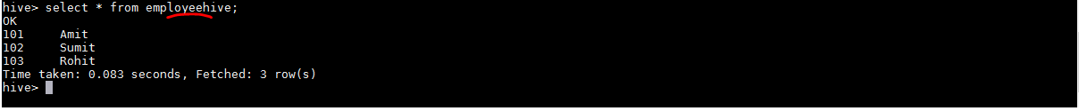

**ii.b)Sqoop Export between Hive and Mysql:**

**Hive table data:**



For export to Mysql – Mysql should have the table existing with same structure as the date to be imported. Hence created a new table “employee1” with selected columns id,name.



**Sqoop export command:**

Export the table "employee" with user "root" only selected columns from Hive to Mysql using Sqoop. Where

**export-dir**  - Hive metastore directory where the data for hive tables resides(source data)

**input-fields-terminated-by**  – to specify delimiter

**m** - to specify the number of mappers involved in this import(in this case -1)

**columns**  - specify columns to be exported(Mysql)





**Exported data from hive to new Mysql table - Data load:**

